*HANDSON - 9*

**ReactJS-HOL**

The objective of this HandsOn is to practice ES6 features such as arrow functions, array destructuring, merging arrays, and conditional rendering within a React application “cricketapp”.

**Steps followed:**

1. Created the React App –

I created a new React app ‘cricketapp’ using command:

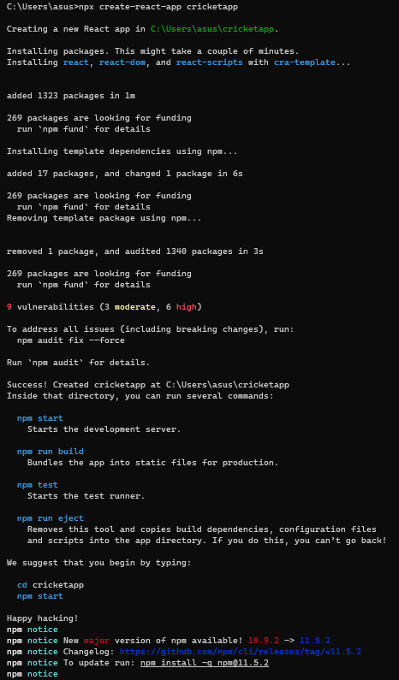

1. Opened the Project in VS Code –

Using command in command prompt:



1. Components used –

Inside the src folder, we created 5 .js files:

1. Created ListofPlayers.js:

function ListofPlayers({ players }) {

return (

<div>

<ul>

{

players.map((item) => {

return (

<li>

Mr. {item.name} <span> {item.score}</span>

</li>

);

})

}

</ul>

</div>

);

}

export default ListofPlayers;

1. Created Scorebelow70.js –

function Scorebelow70({ players }) {

let players70 = [];

players.map((item) => {

if (item.score <= 70) {

players70.push(item);

}

});

return (

<div>

<ul>

{

players70.map((item) => {

return (

<li>

Mr. {item.name} <span> {item.score}</span>

</li>

);

})

}

</ul>

</div>

);

}

export default Scorebelow70;

1. Created OddPlayers.js –

function OddPlayers({ players }) {

const [first, , third, , fifth] = players;

return (

<div>

<h3>Odd Players</h3>

<li>First: {first}</li>

<li>Third: {third}</li>

<li>Fifth: {fifth}</li>

</div>

);

}

export default OddPlayers;

1. Created EvenPlayers.js –

function EvenPlayers({ players }) {

const [, second, , fourth, , sixth] = players;

return (

<div>

<h3>Even Players</h3>

<li>Second: {second}</li>

<li>Fourth: {fourth}</li>

<li>Sixth: {sixth}</li>

</div>

);

}

export default EvenPlayers;

1. Created ListofIndianPlayers.js –

export function ListofIndianPlayers({ IndianPlayers }) {

return (

<div>

{IndianPlayers.map((item, index) => (

<li key={index}>Mr. {item}</li>

))}

</div>

);}

1. Modified App.js to Include All Components –

import React from 'react';

import ListofPlayers from './ListofPlayers';

import Scorebelow70 from './Scorebelow70';

import OddPlayers from './OddPlayers';

import EvenPlayers from './EvenPlayers';

import { ListofIndianPlayers } from './ListofIndianPlayers';

const players = [

{ name: 'Jack', score: 50 },

{ name: 'Michael', score: 70 },

{ name: 'John', score: 40 },

{ name: 'Ann', score: 61 },

{ name: 'Elisabeth', score: 61 },

{ name: 'Sachin', score: 95 },

{ name: 'Dhoni', score: 100 },

{ name: 'Virat', score: 84 },

{ name: 'Jadeja', score: 64 },

{ name: 'Raina', score: 75 },

{ name: 'Rohit', score: 80 }

];

const IndianTeam = ['Sachin', 'Dhoni', 'Virat', 'Rohit', 'Raina', 'Yuvraj'];

const T20Players = ['First Player', 'Second Player', 'Third Player'];

const RanjiTrophyPlayers = ['Fourth Player', 'Fifth Player', 'Sixth Player'];

const IndianPlayers = [...T20Players, ...RanjiTrophyPlayers];

function App() {

const flag = true;

if (flag === true) {

return (

<div>

<h1>List of Players</h1>

<ListofPlayers players={players} />

<hr />

<h1>List of Players having Scores Less than 70</h1>

<Scorebelow70 players={players} />

</div>

);

} else {

return (

<div>

<div>

<h1>Indian Team</h1>

<h1>Odd Players</h1>

<OddPlayers players={IndianTeam} />

<hr />

<h1>Even Players</h1>

<EvenPlayers players={IndianTeam} />

</div>

<hr />

<div>

<h1>List of Indian Players Merged:</h1>

<ListofIndianPlayers IndianPlayers={IndianPlayers} />

</div>

</div>

);

}

}

export default App;

1. Ran the App –

1. Output –
2. When flag = true –

1. When flag = false –

